INNOVATION

Simply put, innovation is about successfully implementing new idea and creating value for your customers and stakeholders

Innovation starts with a new idea.it could be a plan for an improved product or service; it could be an updated method for running your operations; it could also be a new business model.

INNOVATION IN ELECRICITY PRICE PREDICTION

Electricity price has an insignificant relationship with patent counts of renewable energy technologies in the short run indicating that electricity pricing system does not play a role in driving the innovation in renewable energy technologies

The accurate prediction of electricity prices has great significance for the power system and the electricity market, regional electricity prices are difficult to predict due to congestion issues in regional transmission line.

A regional electricity price prediction frame work is proposed based on an adaptive spatial –temporal convolution network.

The proposed framework is expected to better explore regional electricity prices’ spatial- temporal dynamic characteristics in the electricity spot market and improve the predictive accuracy of regional electricity prices

First, different areas of the electricity market are regarded as node.

Then, each area’s historical electricity price data are used as a corresponding node’s characteristic information and constructed into a graph

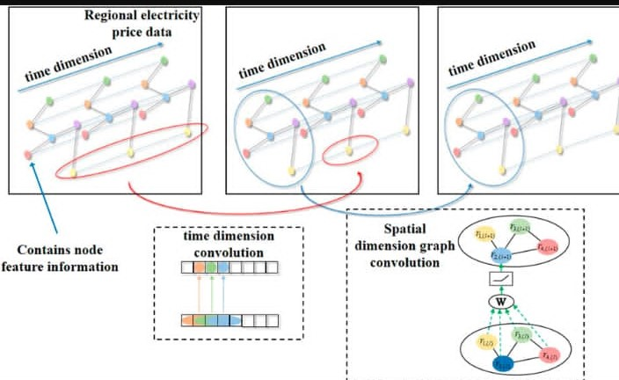

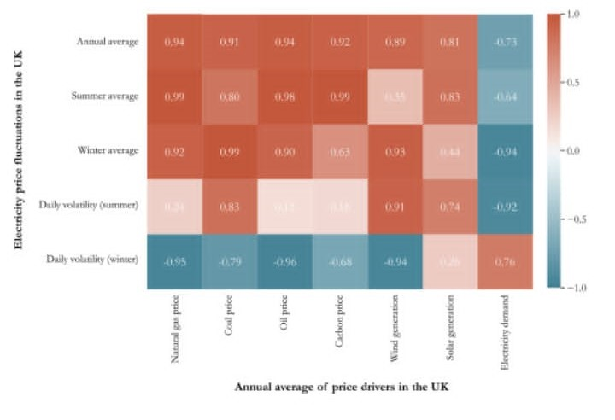

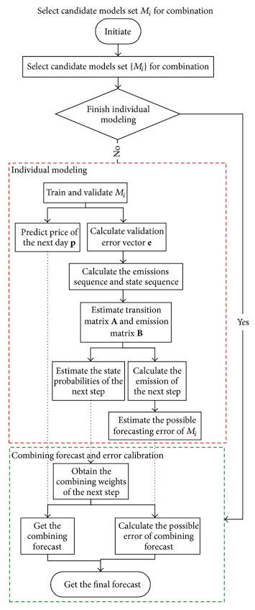

The increasing frequency of cross- regional power market transactions and long distance power transmission affects electricity price fluctuations in different regions